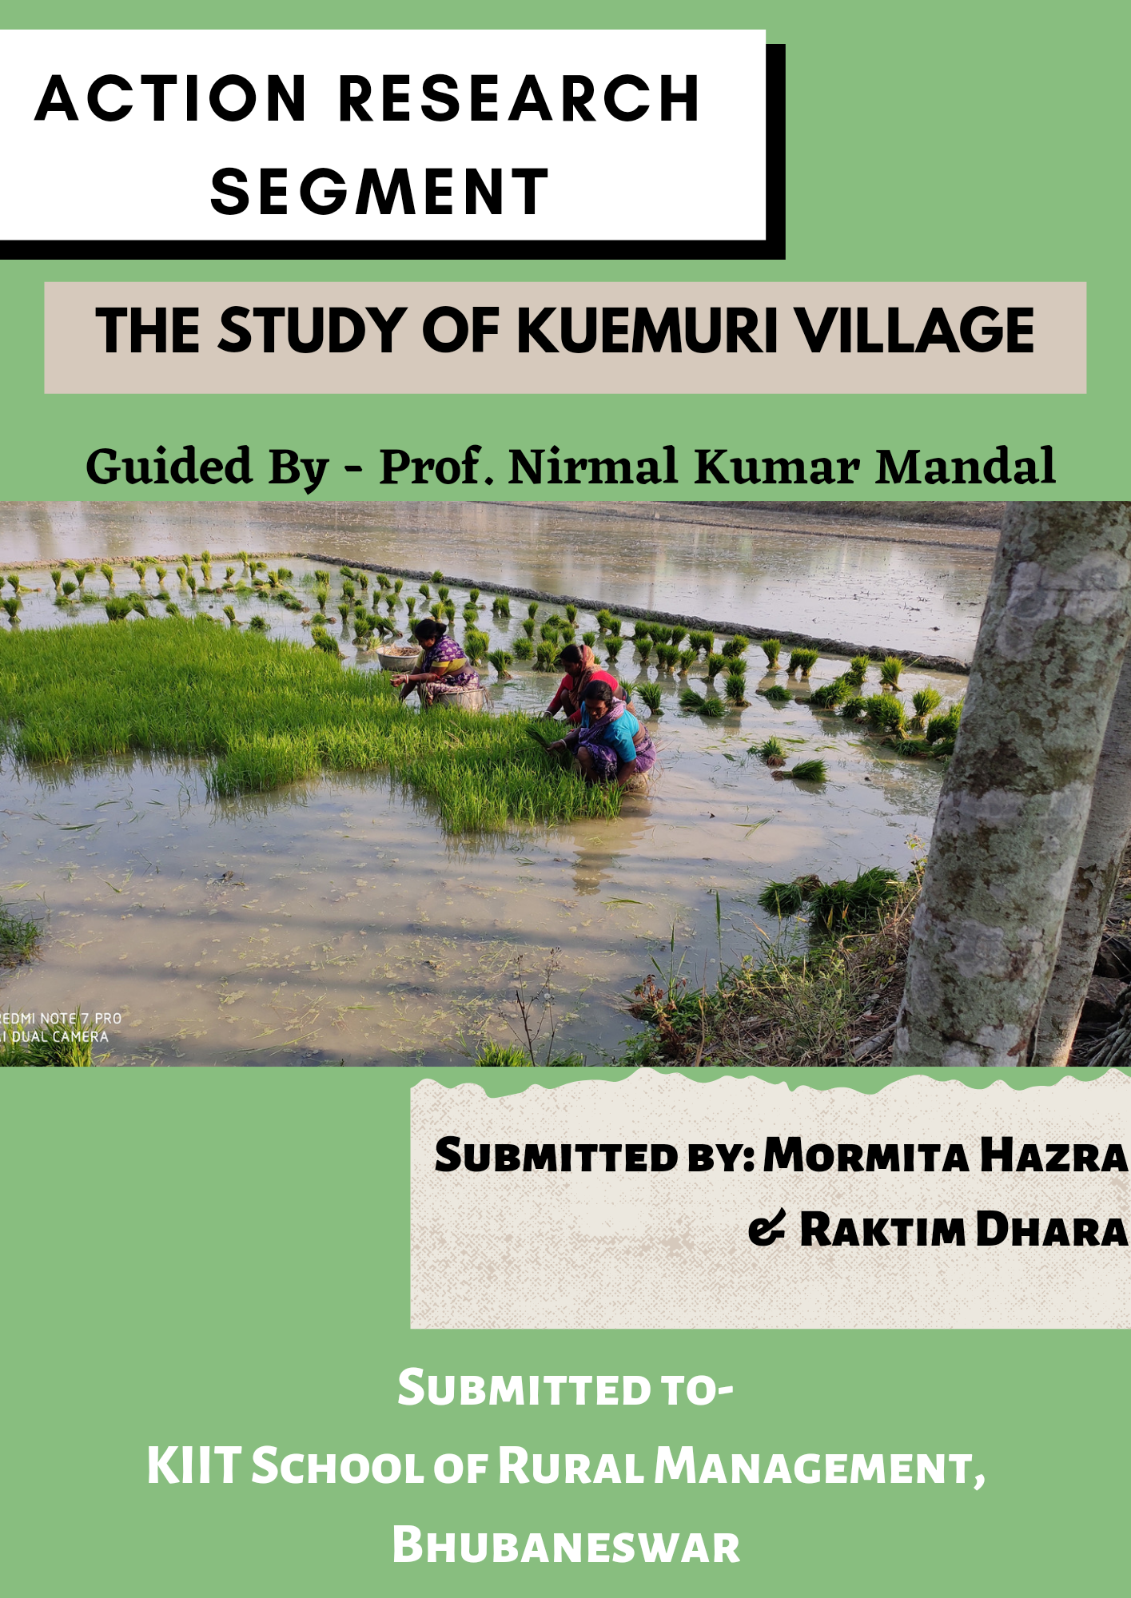

**CERTIFICATE**

This is to certify that Mormita Hazra and Raktim Dhara, student of KIIT School of Rural Management, Bhubaneswar, have successfully completed the Action Research Segment.

Date: 10.02.2021

Place: Bhubaneswar Signature

(Name of the Director)

(College Seal/Stamp)

**DECLARATION**

We do hereby declare that this report of Action Research Segment (ARS) submitted to the KIIT School of Rural Management (KSRM) of KIIT University, Bhubaneswar for the partial fulfillment of the requirement for the Master in Business Administration in Rural Management is of our own and has not at any time being previously submitted to this University or any other Universities/Institutions for award of any degree or diploma.





Place: Bhubaneswar Mormita Hazra & Raktim Dhara

Date: 10.02.2021 (20201035) (20201048)

**ACKNOWLEDGEMENTS**

In the accomplishment of this project successfully, many people have bestowed upon us their blessings and heart pledged support, this time we are taking this opportunity to thank all the people who have been concerned with this project.

Primarily we would thank God for being able to complete this internship program with success. Then we would like to thank our faculty guide Prof. Nirmal Kumar Mandal, whose valuable guidance has been the one that helped us patch our Action Research Segment and make it a success. His suggestions and his instructions have served as the major contributor towards the completion of the program. Our heartiest thanks to KIIT School of Rural Management and The Director Prof. Nishith Parida, Prof. Srilata Patnaik, our ARS coordinator for their throughout support during our field study segment. We are also grateful to Sabuj Sangha for giving us this opportunity.

We would also like to thank Prof. HS Ganesha, Prof. Damodar Jena, Prof. V Venkatakrishnan and Prof. Jyotiranjan Gochhayat who have helped us with their valuable suggestions and guidance, which has been very helpful in various phases of our ARS.

We would also like to acknowledge the many nameless participants who provided the primary and secondary data which provided the basis for this research.

Finally, we would like to thank our families for their encouragement, love and constant support throughout of this study.

**TABLE Of CONTENTS**

Certificate -------------------------------------------------------------------------------------------------------------------- 2

Declaration ------------------------------------------------------------------------------------------------------------------- 3

Acknowledgement --------------------------------------------------------------------------------------------------------- 4

List of Tables ----------------------------------------------------------------------------------------------------------------- 7

List of Figures ---------------------------------------------------------------------------------------------------------------- 7

Abstract ----------------------------------------------------------------------------------------------------------------------- 8

List of Abbreviation -------------------------------------------------------------------------------------------------------- 10

Chapter I: Introduction -------------------------------------------------------------------------------------------------------------------

* 1. Background ------------------------------------------------------------------------------------------------------- 11
  2. About Action Research Segment ---------------------------------------------------------------------------- 11
  3. Host Organization ----------------------------------------------------------------------------------------------- 11
     1. Thematic Areas ----------------------------------------------------------------------------------------- 12
     2. Geographical Coverage ------------------------------------------------------------------------------- 12
  4. ARS Objectives --------------------------------------------------------------------------------------------------- 13
  5. Methodology ----------------------------------------------------------------------------------------------------- 13
  6. Collection of Data ----------------------------------------------------------------------------------------------- 13
     1. Primary Source ------------------------------------------------------------------------------------------ 13
     2. Secondary Source -------------------------------------------------------------------------------------- 14
  7. Sample Design --------------------------------------------------------------------------------------------------- 14
  8. Tools --------------------------------------------------------------------------------------------------------------- 14

Chapter II: About the Village --------------------------------------------------------------------------------------------------------------------------

2.1. Introduction ----------------------------------------------------------------------------------------------------------------- 15

2.2. Geographical Location ---------------------------------------------------------------------------------------------------- 16

2.3. Demographic Details ------------------------------------------------------------------------------------------------------ 16

2.4. Village Economy ------------------------------------------------------------------------------------------------------------ 17

Chapter III: PRA Activities ------------------------------------------------------------------------------------------------------------------------------

3.1. Social Map --------------------------------------------------------------------------------------------------------------------18

3.1.1. Objectives ------------------------------------------------------------------------------------------------------------- 18

3.1.2. Key Findings from the Map --------------------------------------------------------------------------------------- 19

3.2. Resource Map --------------------------------------------------------------------------------------------------------------- 19

3.2.1. Objectives ------------------------------------------------------------------------------------------------------------- 20

3.2.2. Key Findings from the Map --------------------------------------------------------------------------------------- 20

3.3. Transect Walk --------------------------------------------------------------------------------------------------------------- 21

3.3.1. Objectives ---------------------------------------------------------------------------------------------------------- 21

3.4. Historical Timeline --------------------------------------------------------------------------------------------------------- 21

3.4.1. Key Findings -------------------------------------------------------------------------------------------------------- 21

3.5. Venn Diagram and Mobility Map --------------------------------------------------------------------------------------- 22

3.5.1. Frequency ----------------------------------------------------------------------------------------------------------- 22

3.5.2. Importance --------------------------------------------------------------------------------------------------------- 22

3.5.3. Distance ------------------------------------------------------------------------------------------------------------- 22

3.5.4. Key Informant ------------------------------------------------------------------------------------------------------ 22

3.5.5. Key Findings -------------------------------------------------------------------------------------------------------- 23

3.6. Seasonal Calendar ---------------------------------------------------------------------------------------------------------- 24

3.6.1. Key Findings -------------------------------------------------------------------------------------------------------- 24

3.7. Activity Clock ---------------------------------------------------------------------------------------------------------------- 25

3.7.1. Key Findings -------------------------------------------------------------------------------------------------------- 25

Chapter IV: Analysis ------------------------------------------------------------------------------------------------------------------------------------

4.1. Social Category -------------------------------------------------------------------------------------------------------------- 26

4.2. Average Annual Income --------------------------------------------------------------------------------------------------- 26

4.3 . Average Annual Expenditure --------------------------------------------------------------------------------------------- 27

4.4. Average Annual Health Expenses with respect to Sanitation ---------------------------------------------------- 28

4.5. Above 60 Occupational Activeness ------------------------------------------------------------------------------------- 28

4.6. Primary Source of Income ------------------------------------------------------------------------------------------------ 29

4.7. Average Annual Income in terms of Access to Farm Land -------------------------------------------------------- 30

4.8. Local Flora & Fauna --------------------------------------------------------------------------------------------------------- 30

Chapter V: Climate Change ----------------------------------------------------------------------------------------------------------- 31

Key Learnings ---------------------------------------------------------------------------------------------------------------------------- 32

Annexures------------------------------------------------------------------------------------------------------------

**List of Tables**

Table 1: Mobility Map of Kuemuri ----------------------------------------------------------------------------------- 23

Table 2: Local Flora and Fauna --------------------------------------------------------------------------------------- 30

**List of Figures**

Figure 1: Thematic Areas of Sabuj Sangha ------------------------------------------------------------------------- 12

Figure 2: Geographical Coverage of Sabuj Sangha --------------------------------------------------------------- 12

Figure 3: Primary Data Collection ------------------------------------------------------------------------------------- 13

Figure 4: HHs Sample No ------------------------------------------------------------------------------------------------ 14

Figure 5: Location of Kuemuri ------------------------------------------------------------------------------------------ 15

Figure 6: Graphical Map of Kuemuri ---------------------------------------------------------------------------------- 16

Figure 7: Social Map of Kuemuri --------------------------------------------------------------------------------------- 19

Figure 8: Resource Map of Kuemuri ---------------------------------------------------------------------------------- 20

Figure 9: Historical Timeline of Kuemuri Village ------------------------------------------------------------------- 21

Figure 10: Venn Diagram of Kuemuri --------------------------------------------------------------------------------- 22

Figure 11: Seasonal Calendar (Crop) ---------------------------------------------------------------------------------- 24

Figure 12: Activity Clock of Men --------------------------------------------------------------------------------------- 25

Figure 13: Activity Clock of Women ----------------------------------------------------------------------------------- 25

Figure 14: Social Categories of Kuemuri ----------------------------------------------------------------------------- 26

Figure 15: Average Annual Income ----------------------------------------------------------------------------------- 26

Figure 16: Average Annual Expenditure ----------------------------------------------------------------------------- 27

Figure 17: Health Expenses with respect to Sanitation ---------------------------------------------------------- 28

Figure 18: Above 60 Occupational Activeness --------------------------------------------------------------------- 28

Figure 19: Primary Source of Income --------------------------------------------------------------------------------- 29

Figure 20: Average Annual Income with respect to Access to Farm Land ----------------------------------- 30

Figure 21: Destruction by Amphan ------------------------------------------------------------------------------------ 31

**ABSTRACT**

The objective of the study is to profile a village, which should be selected by our own. We have carried out our action research program in the Kuemuri village of Heramba Gopalpur Gram Panchayat, having 1029 HHs. We have used PRA tools like Social map, Resource map, Venn Diagram and Mobility map, Transect walk, Historical Timeline, Seasonal map, Daily Activity Schedule for the purpose of documentation of the selected village, the people residing there, their life and realities and the livelihood systems, to study the economic condition of the village, to study the resource and their distribution, to identify the strength and weaknesses of the village and villagers, to understand and identify the key issues and problems of the village and arrive at the possible best solutions by involving villagers. We have taken a transect walk across the village. PRA Tools were made with the help of villagers and the gram volunteers. 63 Individual HHs survey was taken through simple random sampling. Data Analysis was done from the Sample collected based on their demographic details and other dimensions of information provided in the HH survey format.

As a part of the academics, the Action Research Segment has to be done in a village, with certain requirements. The HH survey format is provided by our institution to collect the data. As the scope of the study is limited to the profiling and interpreting the village condition on different dimensions, the report consists of all the required information for the further studies. Hence, this is a baseline study.

**LIST OF ABBREVIATION**

ARS – Action Research Segment

FPO – Farmers Producer Organizations

HH – Households

GP – Gram Panchayat

IHHL – Individual House Hold Latrine

PDS – Public Distribution System

PRA – Participatory Rural Appraisal

GC – General Caste

SC – Scheduled Caste

ST – Scheduled Tribe

SHG – Self Help Group

**CHAPTER I**

**INTRODUCTION**

**1.1 Background**

From our university we had been given the chance to put in our theoretical knowledge in Rural Management into practical implementation to analyze the minute difference between what we actually studied and what it depicts. Through this Research Segment we get to interact with rural people, get to evolve ourselves with the rural life. As we both being a person from the urban society we had hands on experience with the rural immersion. In India, agriculture sector being the primary contributors in the economy, the role of rural areas in India and its development can be a major cause as to why rural society of our country are still the backbone of our nation as it provides, labour, land for cultivation which are used by the entire nation, this Program has made us understand the rural dynamics.

**1.2 About Action Research Segment**

ARS or Action Research Segment is a programme for implementing theoretical knowledge into practical output. The aim of this program is to get an insight of the prospective village through analyzing its social, economic characteristics. This research programme help us, the management students to connect with rural people and rural life to develop an understanding about the difference between the illusion and reality.

**1.3 Host Organization**

Sabuj Sangha is a non-government civil society organization working in an integrates and sustainable approach towards the betterment of the lives of disadvantaged communities in West Bengal, India. It adopts a participatory process and focuses on the empowerment of local communities, especially women. Sabuj Sangha evolved out of a social club initialed in 1954 in the village of Nandakumarpur in South 24 Parganas, West Bengal. In the initial years, Sabuj Sangha became involved in local efforts to enhance the wellbeing of communities living in the region. In 1975, the organization was registered under West Bengal Society Registration Act, 1961. Since then, it has grown into a state level organization working intensively in three districts in development programs and continuously expanding its reach in terms of geography and focus areas. It addresses a wide range interlinked developmental issues faced by poverty-stricken communities and their children.

**1.3.1 Thematic Areas**

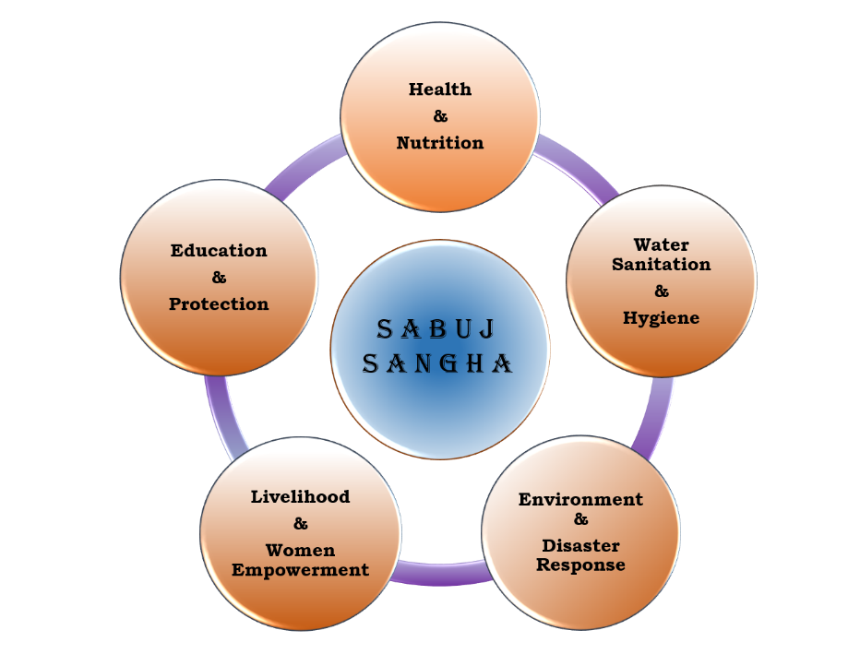

Figure Thematic Areas of Sabuj Sangha

Sabuj Sangha mainly works on five sectors, those are Health & Nutrition, Water Sanitation & Hygiene, Environment & Disaster Response, Education & Protection and last but not the least Livelihood & Women Empowerment.

**1.3.2 Geographical Coverage**

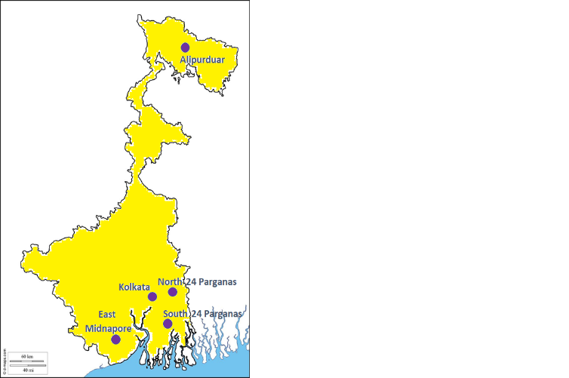Sabuj Sangha mainly operates in 5 districts of West Bengal. Those are Alipurduar, Kolkata, East

Midnapore, North 24 Parganas and South 24 Parganas.

South 24 Parganas: Mathurapur I, Mathurapur II, Patharpratima, Sagar, Baruipur, Sonarpur, Canning I, Jaynagar I and Kulpi Bocks.

Alipurduar: Kumargram and Madarihat Bock

Kolkata: Kolkata Municipal Corporation, Bidhannagar Municipal Corporation

East Midnapore: Mahishadal and Haldia Blocks

Figure Geographical Coverage of Sabuj Sangha

**1.4 ARS Objectives**

* To get an inmate idea about village life – the difference between the expectations and realities
* To understand the socio-economic and cultural behavior of the residents
* To learn systematic collection and analysis of data for the purpose of targeting the problems and to derive a solution through the help of villagers.

**1.5 Methodology**

We have done our Action Research Segment at Kuemuri village, which comes under Heramba Gopalpur gram panchayat and Patharpratima block of South 24 Pargana, West Bengal. The village consists of 1029 households. On the second day we had taken a transact walk with some villagers to get an overview of the village. We also tried to socialize with the villagers to build a rapport with them and with their help we have implemented some of the PRA tools. Primary sources of all our data taken from 63 households and one of the key informants of the village, Sushanta Kumar Mondal. Our secondary data sources are Gram Panchayat records, Census data (2011), village volunteer and our host organization. Data Analysis was done from the sample collected based on their demographic details and other dimensions of information provided in the HH survey format.

**1.6 Collection of Data**

**1.6.1 Primary Source**

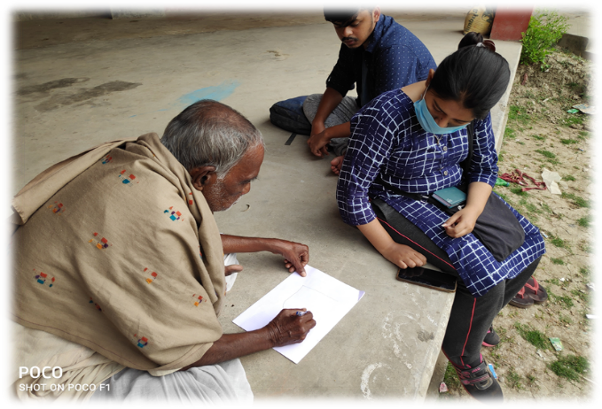We have used different methods to collect the data. We have collected data directly from households by using questionnaires, which was provided by the KIIT School of Rural Management. Through household survey we came to know about the living style, family size, income, expenditure, housing condition and various infrastructure details of the villagers. The village volunteer of the village, Sushanta Kumar Mondal has given information about the village on all the sectors. With his help, we have conducted some of our PRA activities. From our PRA tools we got some information like structure, culture, institutions, resource, history, landholding, crop pattern, activities and so on that one need to know about the village.

Figure Primary Data Collection

**1.6.2 Secondary Source**

We have also got some key information like how many households are there in the village, total population in the village, how many of them are male or female, which social categories they belong, total landholdings of the farmers from the Heramba Gopalpur gram panchayat office. Our village volunteer, Pranab Karmakar also gave us some key insights about the villagers. Our host organization, Sabuj Sangha also helped us to enormously to successfully complete our Action Research Segment.

**1.7 Sample Design**

We have done the sampling through Simple Random Sampling with the help of Randomizer website. Out of the total 1029 households, we have taken out 64 samples in 2 sets each of them consisting 32. Out of those, one household was common for both of us (HH no. 244). So, we have omitted that one and collected data from remaining 63 households.

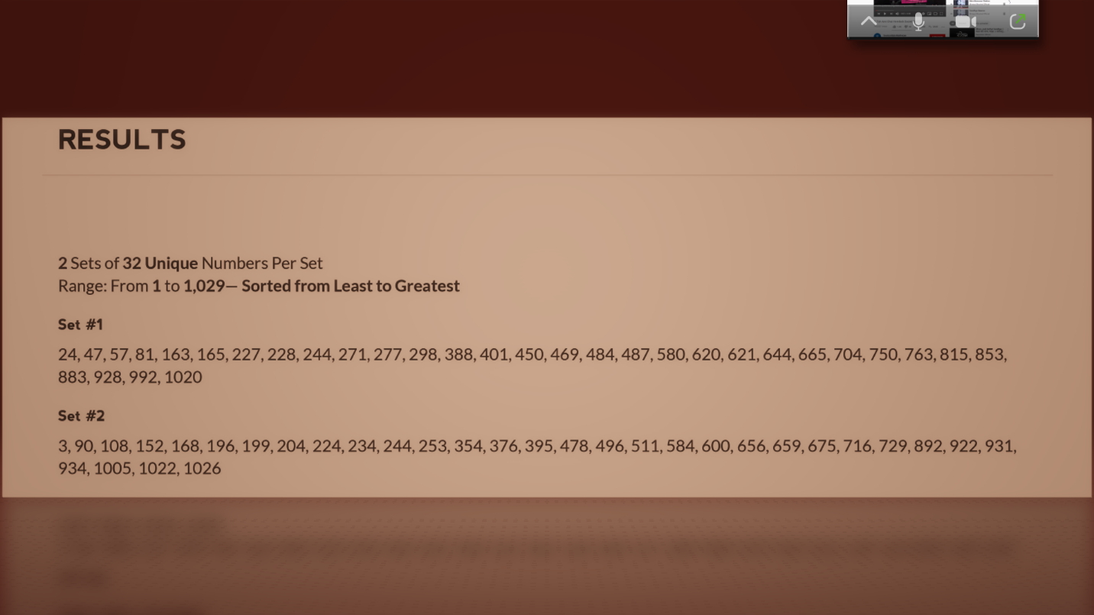

Figure Household Sample Numbers

**1.8 Tools**

After completion of our data collection, various statistical tools like tables, bar diagrams, pie charts are used to represent those data. Measures of central tendencies like mean, median, mode are also used to compare different data.

**CHAPTER II**

**ABOUT THE VILLAGE**

**2.1 Introduction**

Kuemuri village under Heramba Gopalpur which resides under Patharpratima Block in South 24 Parganas, West Bengal. Mainly known for its Rice Cultivation. This village is near Sundarbans area and because of being close to sea level they face many challenges like cyclones which tends to increase the vulnerability aspects of their life. Inaccessibility of Market and proper availability of Transport make their life difficult.

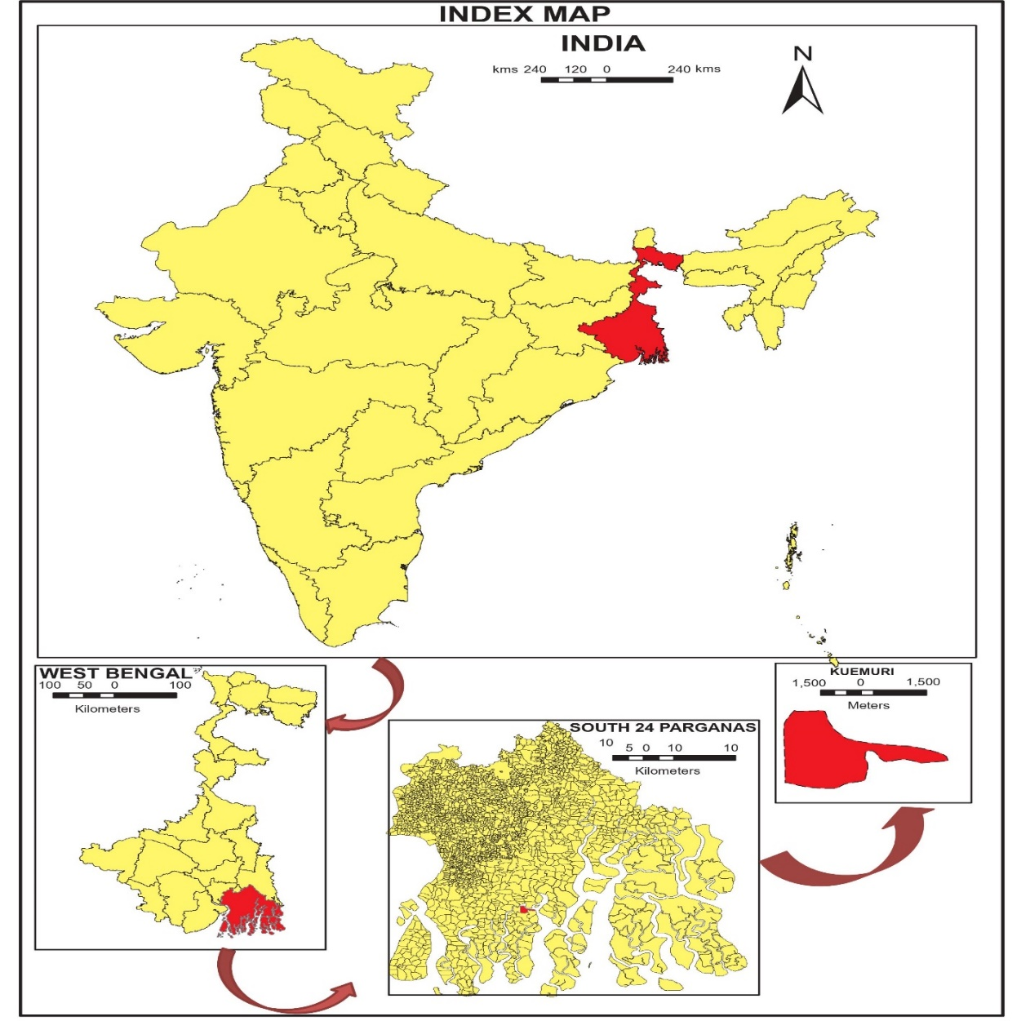

Figure Location of Kuemuri

**2.2 Geographical Location**

The above figure portrays the key map of the village, Kuemuri. The village is situated near the delta region of West Bengal. It is one of the villages among the other 3 villages under Heramba Gopalpur Gram Panchayat, which belongs to Patharpratima block of South 24 Parganas in West Bengal, India. This region is predominantly agricultural areas of West Bengal. The following base map is prepared in ArcGis software.

The map below this enumerate the physical features and direction of surrounding places.

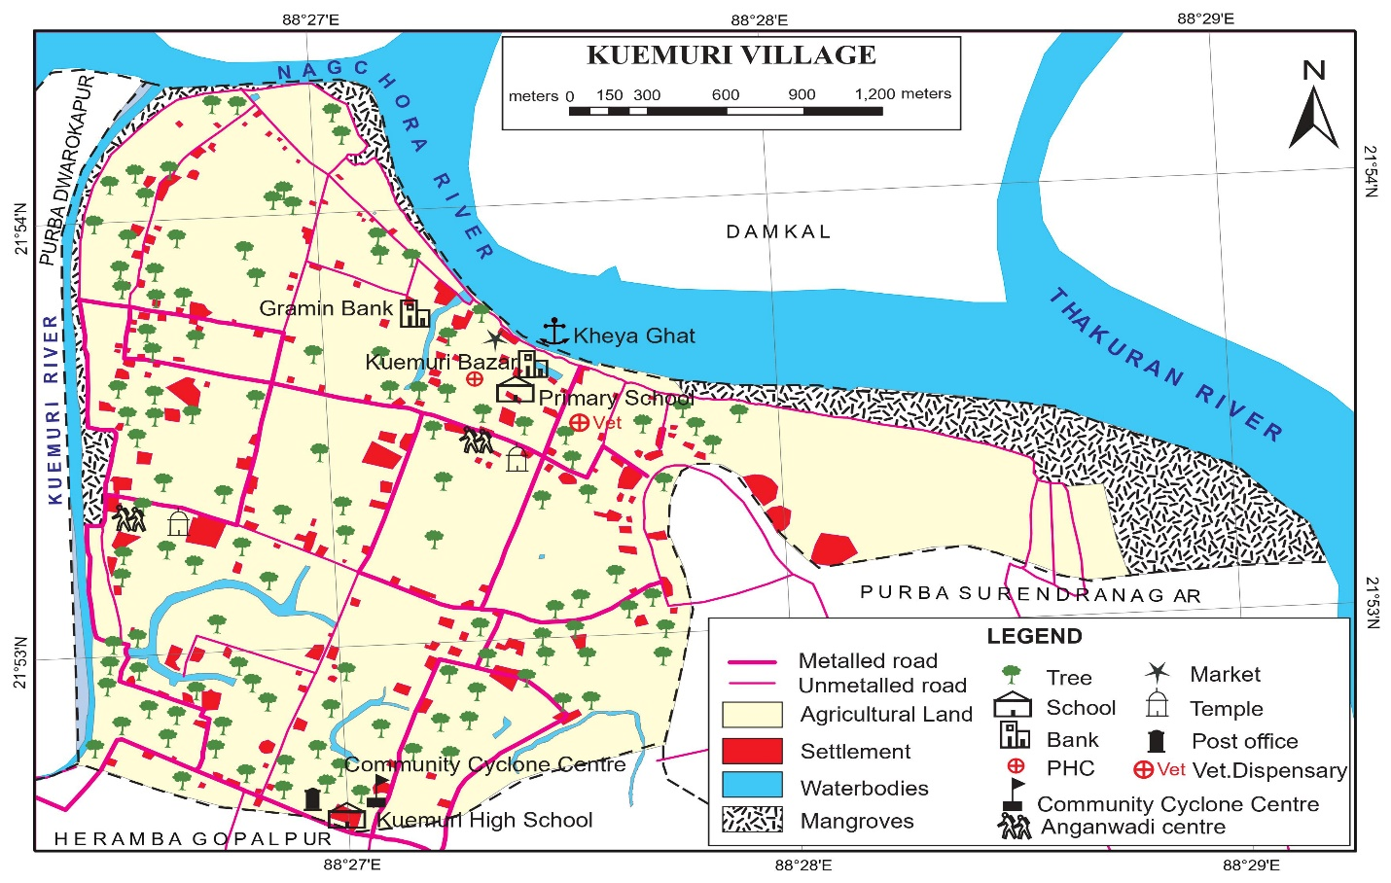

Figure Graphical Map of Kuemuri

**2.3 Demographic Details**

* Population: 5096; No of HHs: 1029 (according to 2011 census data)
* Social Category: **GC** – 68.23%, **SC** – 30.2%, **ST** – 1.43%, **OBC** – 0.14%
* Religion: Hindu – 5089, Muslim – 7
* Food Security Card: 99.99% People are having Food Security Card
* Male Population: 2556; Female Population: 2540

**2.4** **Village Economy**

The economy of the Kuemuri Village evolves around agriculture, most common grown crops are Paddy, Cauliflower, Cabbage, Potato, German Turnip, Spinach etc. in winter season; whereas in summer they mostly produce crops like Potato, Onion, Snake Gourd, Ridge Gourd, Pointed Gourd, Pumpkin, Cowpea etc. The villagers are also associated with many allied services like Livestock Rearing, Agri Labour etc. In this village they practice traditional way of Paddy Cultivation but in last 5 to 6 years with the help of the host organization ‘Sabuj Sangha’ they are experimenting with SRI process of Paddy Cultivation which is helping them to increase their production. But not all the villagers are practicing this process and other than this main problem they face regarding agriculture is absence of proper facilitated market in that area so it is resulting many of the villagers to migrate other states and places like Kerala, Delhi, Mumbai, Kolkata etc. for other jobs.

**CHAPTER III**

**PRA ACTIVITIES**

PRA or Participatory Rural Appraisal is a method to engage local people to share, enhance and analyze their knowledge about their life and conditions or situations in that specific area and to plan for development and to act on that. Through this process WE the management and development people collect the data and analyze it depending upon that, what further work can be done for upgrading their conditions. As it involves the local rural people and they talk about their situations it is a type of “bottom-up Approach”. This is one of the main components of Rural Study in any village. The various tools which we will be using in the village Kuemuri are as follows:

**3.1 Social Map**

This map enumerates the social structure of a village. This map is mainly drawn by the villagers through engaging in a discussion. The focus here is on the depictions of habitation patterns, the nature of housing and the social infrastructure like: roads, drainage systems, schools, drinking water facilities etc. It is not drawn to scale, it only describes what the village residences believe to be relevant and important to them. Thus, it reflects the perception of the social dimension with the actual reality.

**3.1.1 Objectives**

* To develop a comprehensive understanding of the physical and social features of a village.
* To engage village people in an open discussion about their life.
* To learn about the social dimensions from the host village perspectives.
* To serve as a monitoring tool which will help to draw inferences later on.

As our village is/ was quite large so we could not include the whole part of the area in the social map, we only tried to bring forward one part of the village to get an idea about the specific area.

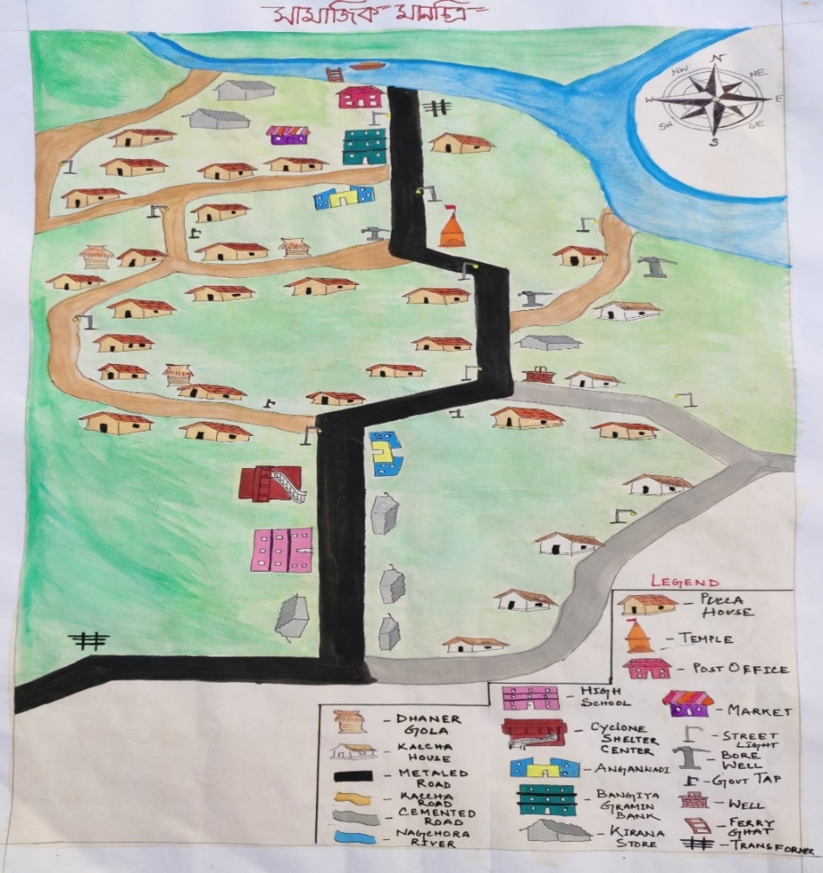

Figure Social Map of Kuemuri

**3.1.2 Key Findings from the Map**

This village, Kuemuri is situated in the South 24 Pargana district of West Bengal. There are total 1029 households. Most of the houses are pucca houses. But there are also some kutcha houses. There are 2 primary schools, 1 high school, 2 anganwadis, 1 Bank, 1 ferry ghat, 1 cyclone shelter, 2 temples, 3 transformers, 15 street lights, 19 bore wells, 1 open well, 2 types of roads (kutcha and pucca) and multiple kirana stores present there.

**3.2 Resource Map**

This is one of the most commonly used PRA methods. While the social map draw attention towards the habitation of the village and the institutions over there and how the infrastructures are. The Resource map focuses on the natural resources available in that area like land, ponds, rivers, vegetative cultivated area, hills etc.

The Resource Map is not drawn to scale and it is also done by the local people. It is believed that they are having in depth knowledge about their locality so the depiction by them must be accurate

**3.2.1 Objectives**

* Through this we get an idea about how residents see their village in terms of availability of natural resources and in perspective of using that.

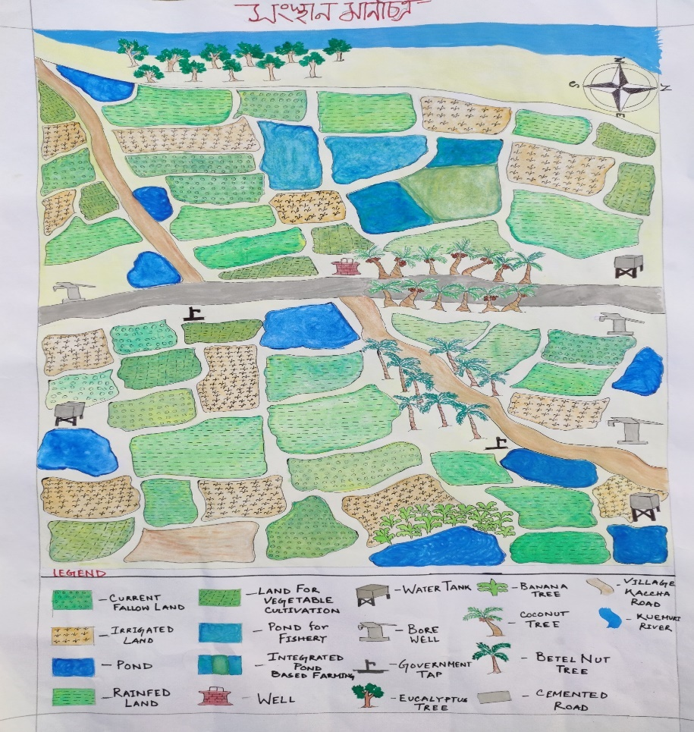

Figure Resource Map of Kuemuri

**3.2.2 Key Findings from the Map**

Kuemuri shares its border with three different rivers. Those are Kuemuri River, Nagchora River and Thakuran River. There are total 4 types of lands, Current fallow land, Irrigated land, Rainfed Land and Land for vegetable cultivation. Different types of trees are also present there like Banana, Coconut, Eucalyptus, Betel nut trees etc. kutcha and pucca both types of roads are also there. Government also provides some taps in that village. Water tanks are used for the agricultural purpose.

**3.3 Transact Walk**

Transact Walk gives us the brief distinction between official data and actual people’s reality. It provides us with a cross sectional study of that ecological zone and through which we can compare about certain factors including land type, land usage, soil type, soil fertility, ownership, access, crops, problems etc. in this facilitators and villager together take a walk in the respective village on a defined path.

**3.3.1 Objectives**

* Get an inmate idea about the village and connect more with the villagers
* Identifying the natural resources in terms of their problems and potentiality.
* Monitoring and evaluation of interventions and projects have been taken over the years.

**3.4 Historical Timeline**

Historical timeline helps us to understand how the village developed over a period of time.

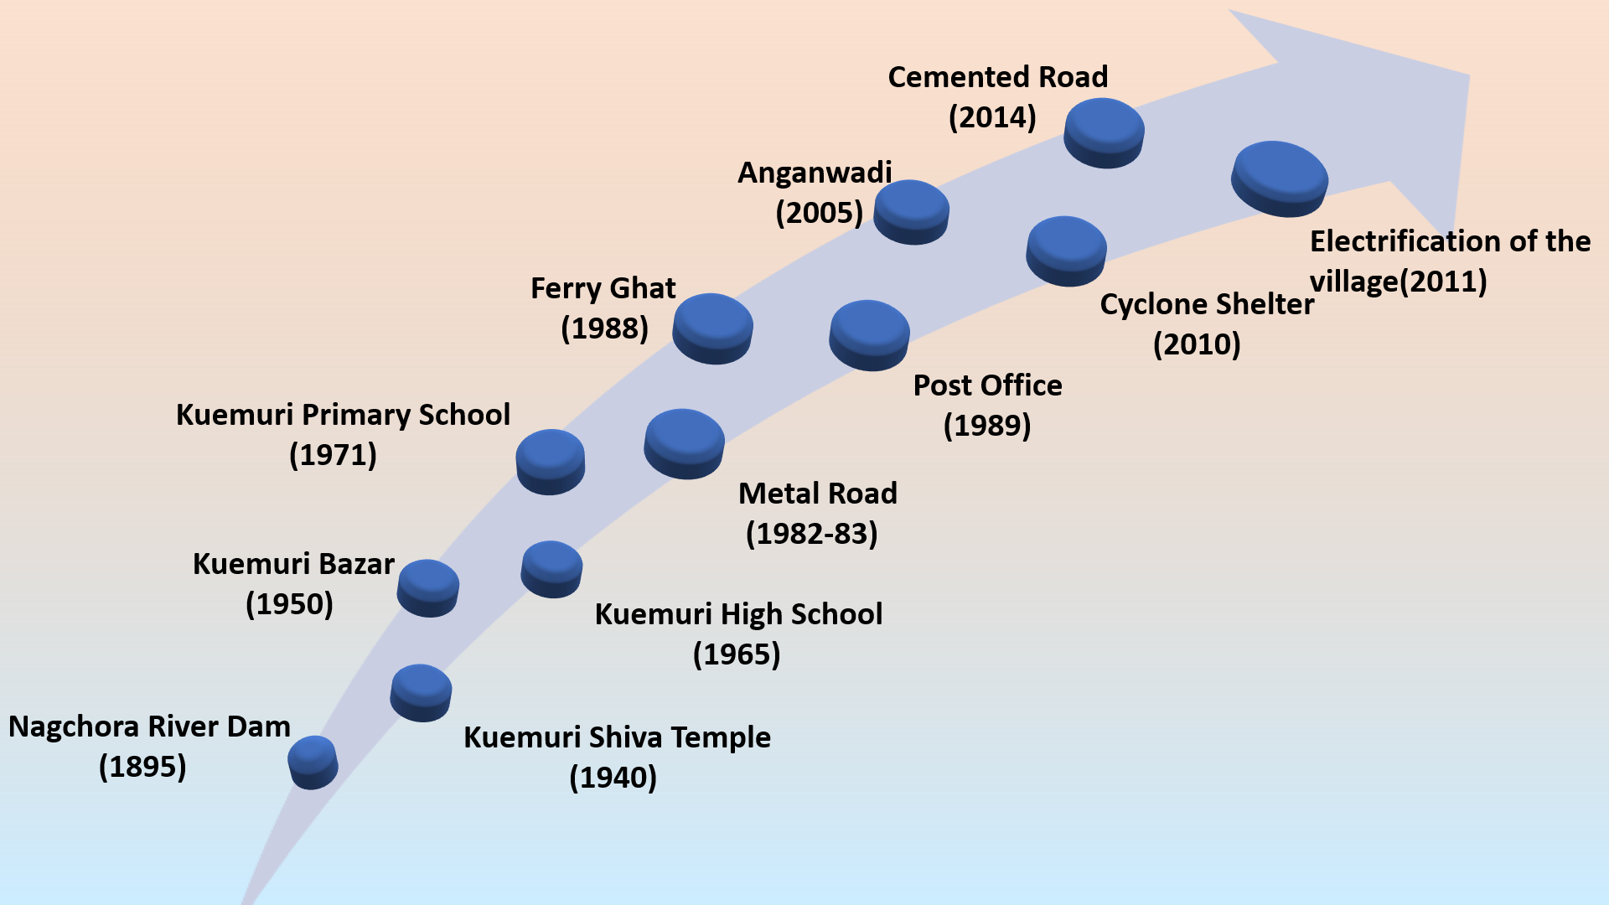

Figure Historical Timeline of Kuemuri Village

**3.4.1 Key Findings**

The village mainly came into life after the construction of the dam around the Nagchora river in the year of 1895. Then little by little development of the village started. Kuemuri High School (1895), Kuemuri Primary School (1971), Ferry Ghat (1988), Post Office (1989) were built in the 20th century. Though the first-time electricity came to the village in 2006, but electrification of the whole village was completed in 2011.

**3.5 Venn Diagram and Mobility Map – Venn diagram**

Mobility Map is a tool to understand movement pattern of an individual, a group or a community. It also helps us to get an idea where people go and for what reason, how often they visit the place, how far is the place and why the place is important for them.

**3.5.1 Frequency**

Thickness of the lines indicates how much the places attached with the villagers. The more the thickness the more it is attached. Similarly, less thickness means less attached.

**3.5.2 Importance**

Importance of the places is indicated by the size of the circle. The bigger the circle is, the more important that place is.

**3.5.3 Distance**

Distance of the place is indicated by the length of the lines. The more the length is, the more it is far from the village. Shorter lines indicate that the place is near to the village.

**3.5.4 Key Informants**

# Sushanta Kumar Mondal

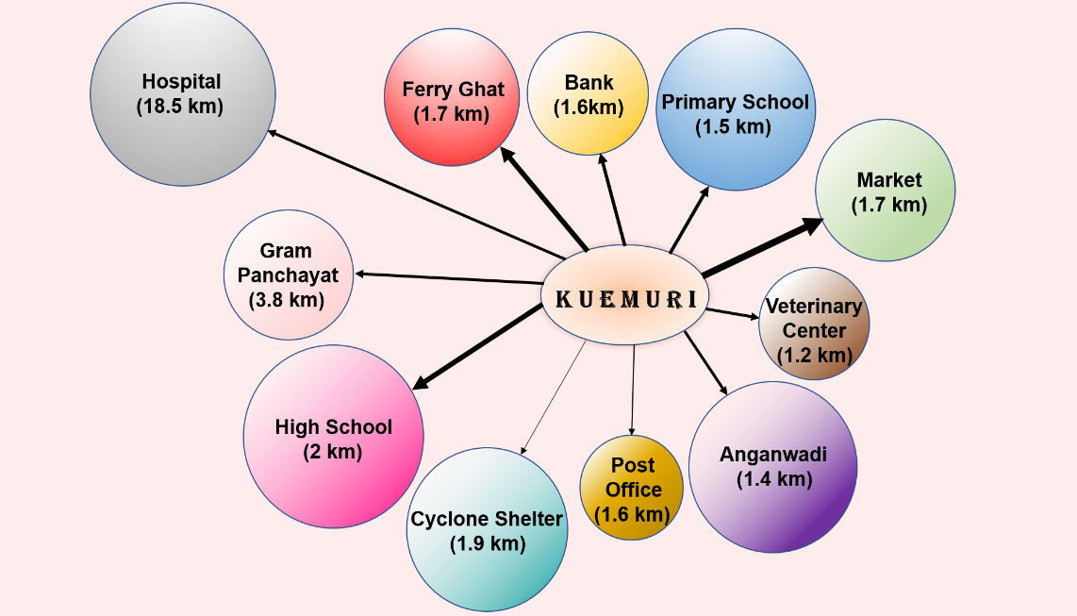

Figure Venn Diagram of Kuemurii

|  |  |  |  |
| --- | --- | --- | --- |
| **SL NO.** | **INFRASTRUCTURE** | **WITHIN THE VILLAGE** | **DISTANCE COVERED** |
| **1** | **Primary School** | **Yes** | **1.5** |
| **2** | **High School** | **Yes** | **2** |
| **3** | **Hospital** | **No** | **18.5** |
| **4** | **Market** | **Yes** | **1.7** |
| **5** | **Cyclone Shelter Center** | **Yes** | **1.9** |
| **6** | **Bank** | **Yes** | **1.6** |
| **7** | **Gram Panchayat** | **No** | **3.8** |
| **8** | **Ferry Ghat** | **Yes** | **1.7** |
| **9** | **Post Office** | **Yes** | **1.6** |
| **10** | **Anganwadi** | **Yes** | **1.4** |
| **11** | **Veterinary Center** | **Yes** | **1.2** |
| **12** | **College** | **No** | **17.6** |

Table Mobility Map of Kuemuri

**3.5.5 Key Findings**

One of the main problems for the villagers is the position of the hospital, which very far from the village (almost 18.5km). Though the frequency is not that much high but still health facilities are important for any community. The market area has the one of the highest frequencies than other areas in the village. Ferry ghat, gramin bank, post office all are connected with the market area. Ferries are one of the most used transport mediums for the villagers. I also want to highlight one more place, which is the Cyclone Shelter. The village is situated in a cyclone prone area, that’s why this place is very important for the villagers. Though the frequency is very low and we can hope that it stays like that.

**3.6 Seasonal Calendar**

This PRA tool has been used to analyze the annual cycles of climate change, with respect to months and seasons as the basic unit of analysis. It is helps us to understand the type of agricultural activities happen with change in weather, climate; such as what type of crops grown in the month of January or in winter.

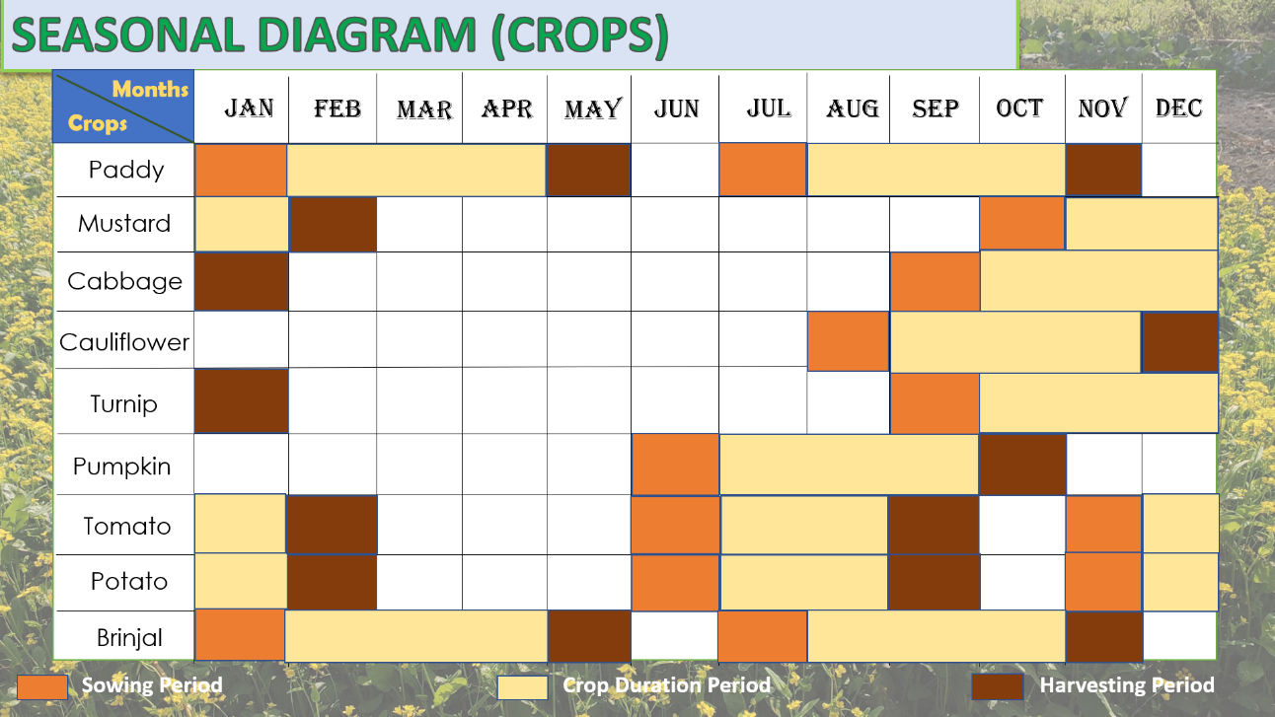

Figure Seasonal Diagram (Crops)

**3.6.1 Key Findings**

Paddy is the most cultivated crop in that area. Villagers used to cultivate paddy twice in a year. Once as a rabi crop in the month of January to May and another time as a kharif crop in the time of July to November. Apart from this, they grow seasonal vegetables throughout the year like cabbages, cauliflowers, turnips, pumpkins, brinjals etc.

**3.7 Activity Clock**

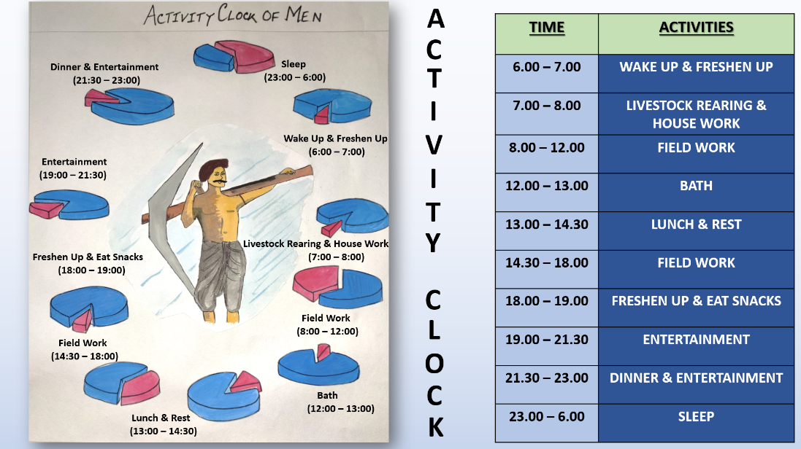

Figure Activity Clock of Men

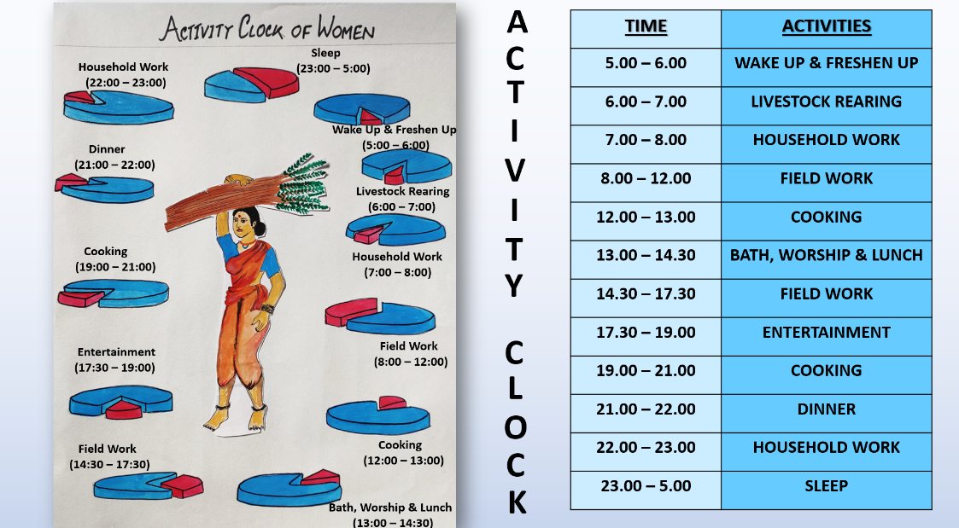

Figure Activity Clock of Women

**3.7.1 Key Findings**

From the map we can see that both men and women spend almost equal amount of time in the field. But women also spend more than thrice amount of time than men in the household works. Whereas men spend almost double amount of time for the entertainment than the women.

**CHAPTER IV**

**ANALYSIS**

**4.1 Social Category**

There are total four different types of social category’s people present in the village. Among 63 households 36 households are in general category, 22 are in ST category, 3 of them are in SC and remaining 2 households are in OBC category.

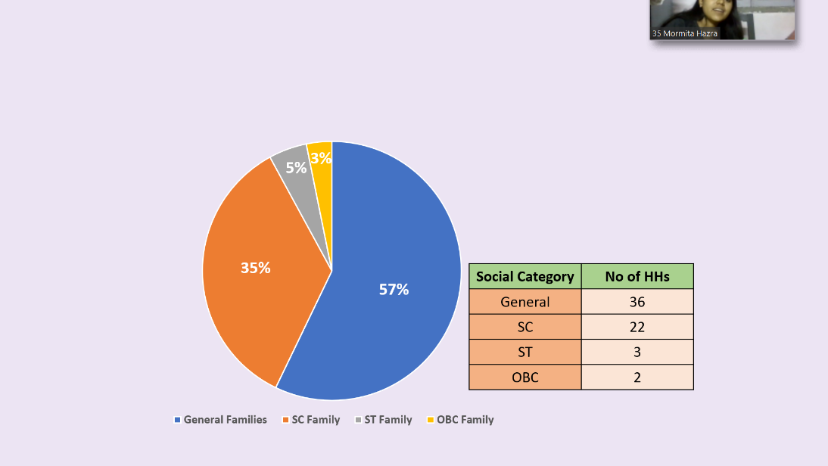

Figure Social Categories of Kuemuri

**4.2 Average Annual Income**

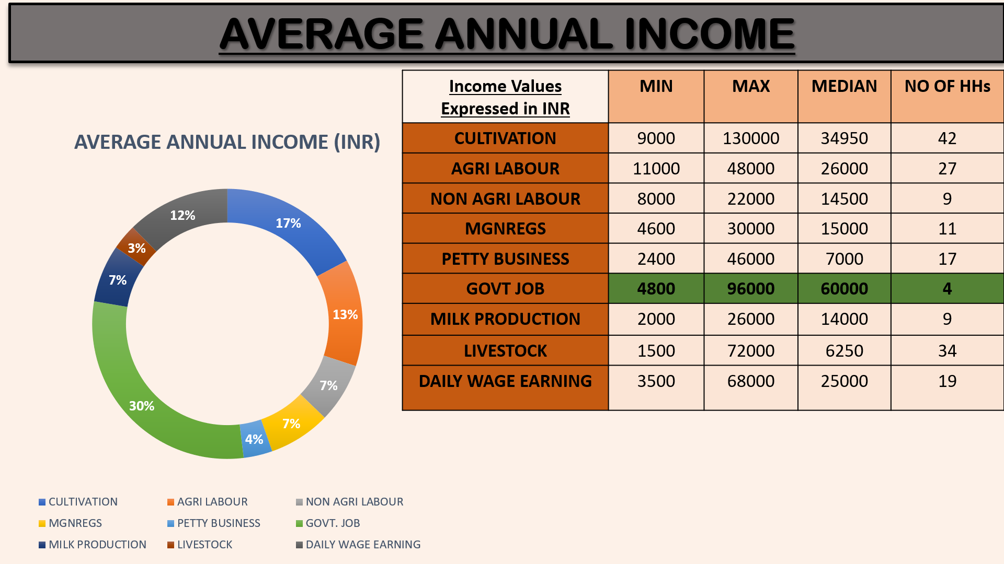

Figure Average Annual Income

This is the pie of the average annual income of the households. As we can see that the difference between minimum and maximum is very high, that’s why we have taken median for calculate averages. Here we can observe that maximum no of households involved with cultivation, followed by livestock rearing. Though average income is high in those households, where any member of the household works in govt sector. Then comes cultivation, agri labour, daily wage earning and other activities.

**4.3 Average Annual Expenditure**

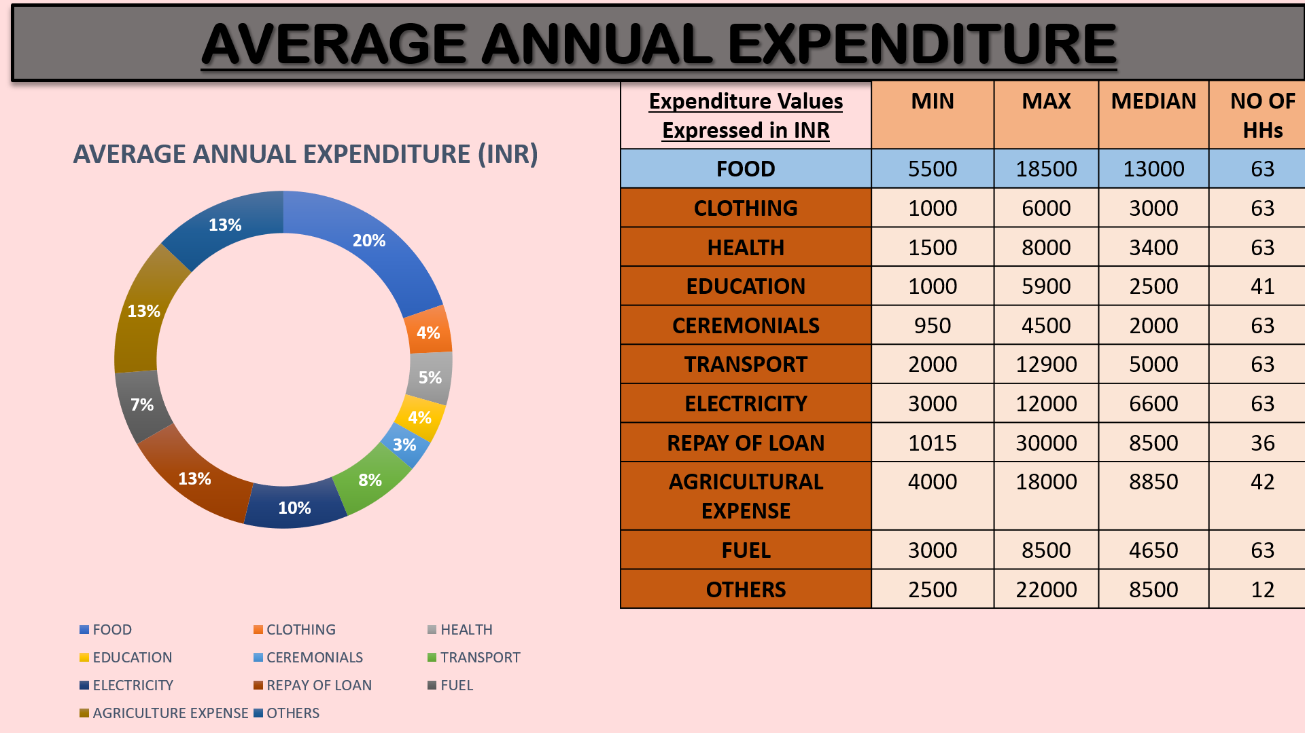

Figure Average Annual Expenditure

Here is the annual expenditure graph of the households. Here also we have taken median to calculate average. All the households spend some amount of money in food, clothing, health, ceremonials, transport, electricity and fuel. So, we can say that there is electricity in every households, they are religious people and spend most of their income on foods, which is almost 20% of their total expenditure. Only 41 households spend on education, because there are students on those households.

**4.4 Average Annual Health Expenses with respect to Sanitation**

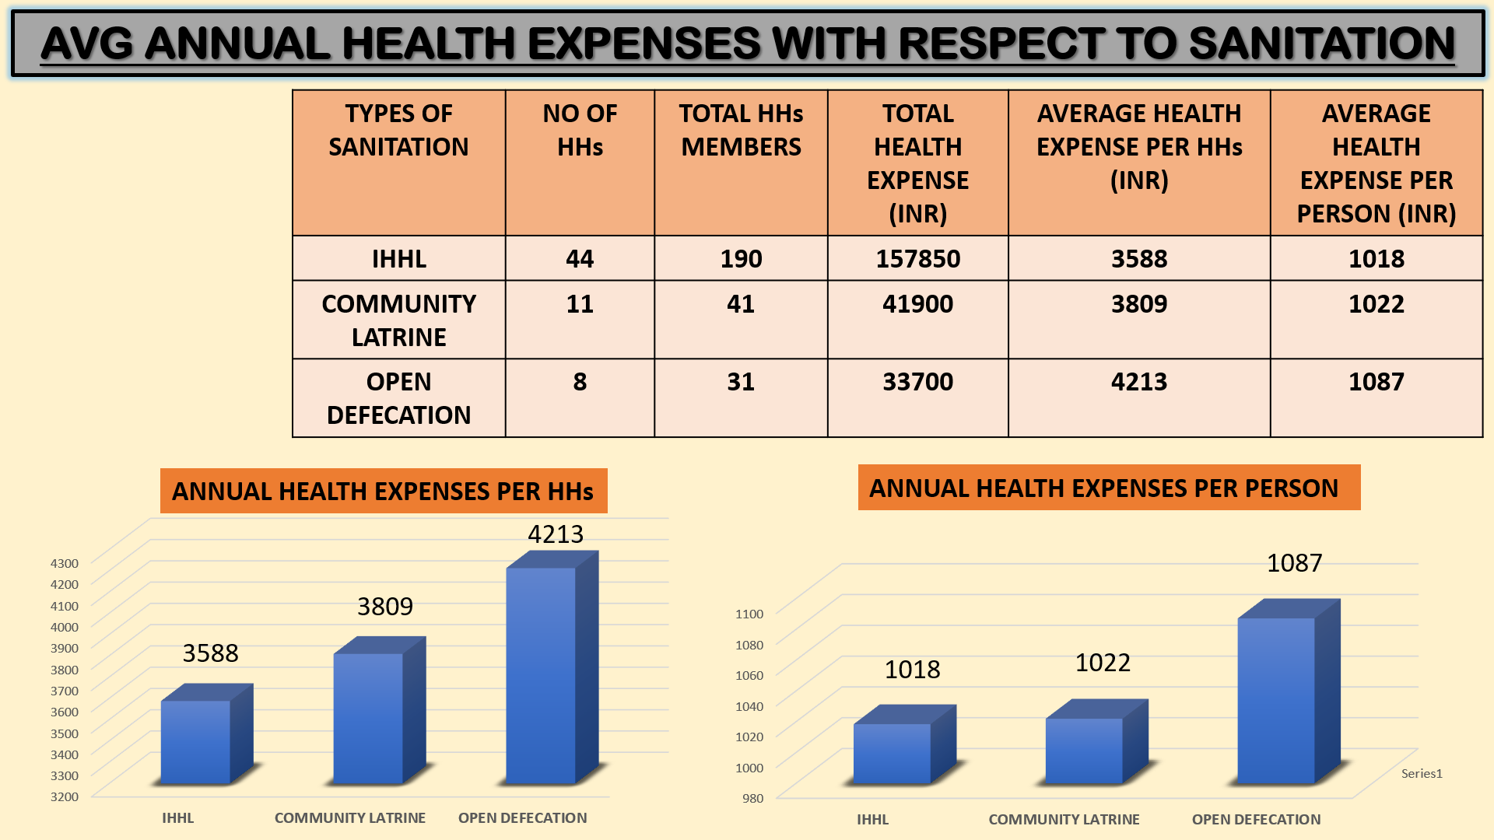

Figure Health Expenses with respect to Sanitation

Here we can see that 44 households use Individual Household Latrines (IHHL), 11 use Community Latrine and 8 households use Open Defecation. So, we have analyzed from data we collected from the village that whichever family use open defecation, their annual health expenditure is higher than the families who use IHHL or community latrines. Though there is not much difference between IHHL households and the households, who use community latrines.

**4.5 Above 60 Occupational Activeness**

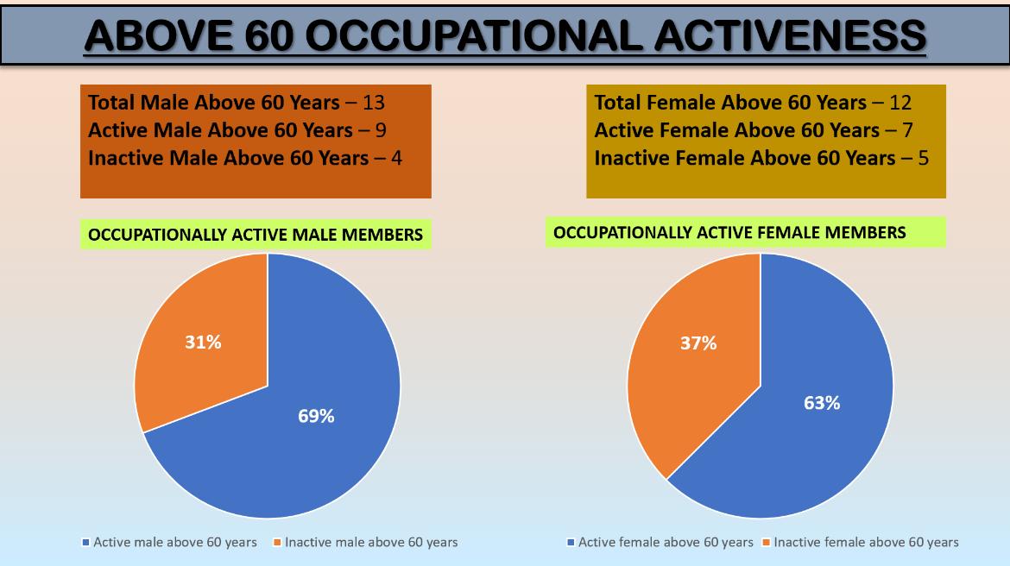

Figure Above 60 Occupational Activeness

We have seen that in the rural areas people started to contribute less economically and also physically after the age of 60. But in Kuemuri village the scenario is slightly different. From the total 63 households, we can see that almost 69% of the male and 63% of female are very active even after their 60s. They work in the field, work as an agri labour and also participate in other areas. They also contribute in their family’s income. So, we can clearly say that age is just a number for them.

**4.6 Primary Source of income**

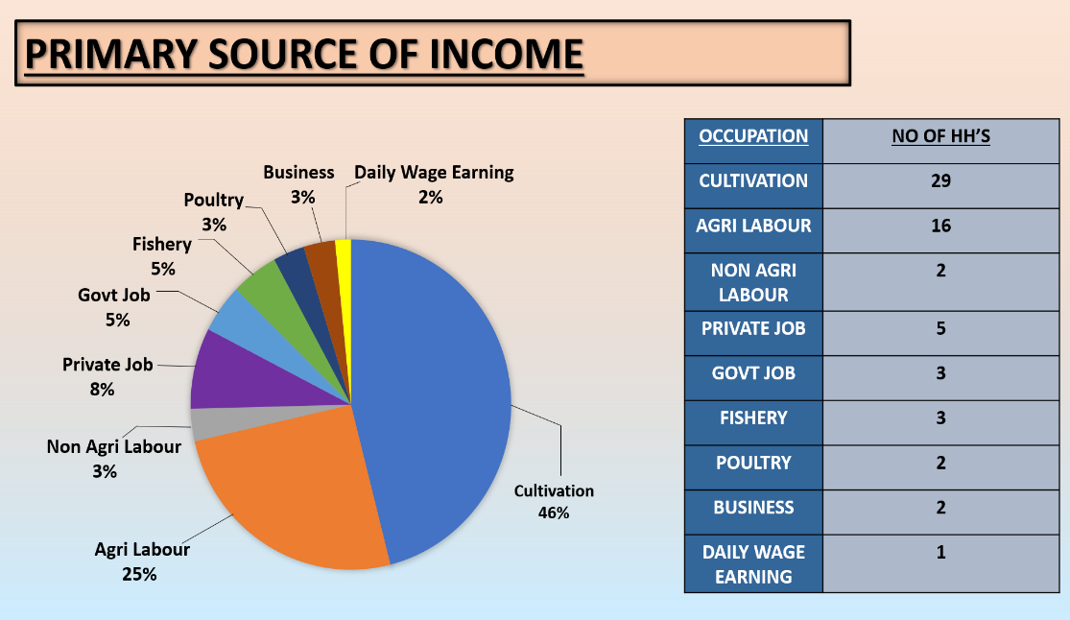

Figure Primary Source of Income

We know that primary source of income is defined as the occupation which gives the highest income in a particular year. So, despite engaging with different activities, cultivation is still the primary source of income for 29 households, which is almost 46% of the 63 households. Agri labour ranks 2nd and in the third position private job comes.

**4.7 Average Annual Income in terms of Access to Farm Land**

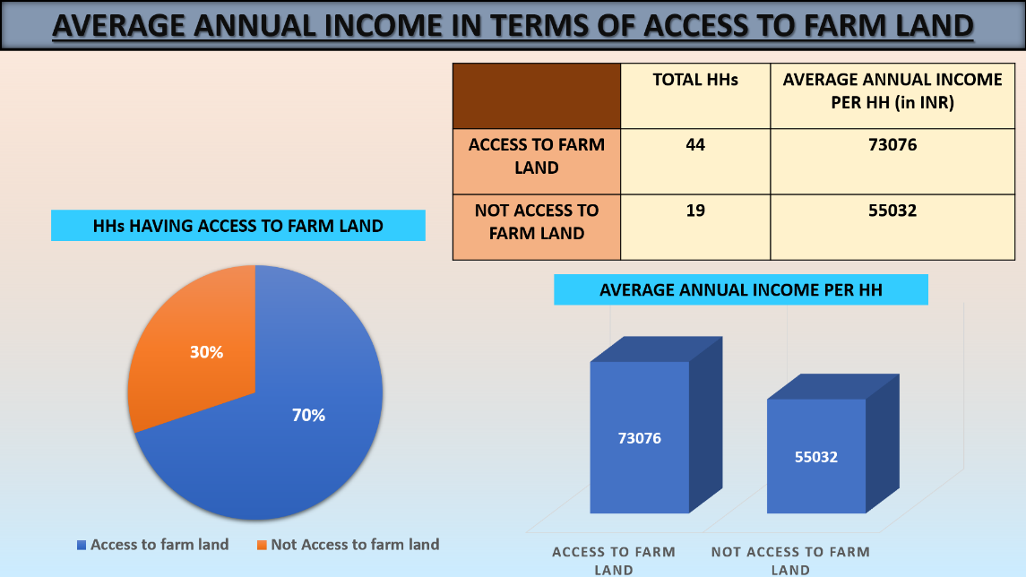

Figure Average Annual Income with respect to Access to Farm Land

As per our sample data, 70% of the people have access to farm land and 30% don’t have. The people who don’t have access to farm land mainly associated with agri labour, non-agri labour and petty businesses. Income is not that much high in those sectors as compared to cultivation. Here we can see that those people who have the access of farm lands earns more than the people who don’t have access of the farm land.

**4.8 Local Flora & Fauna**

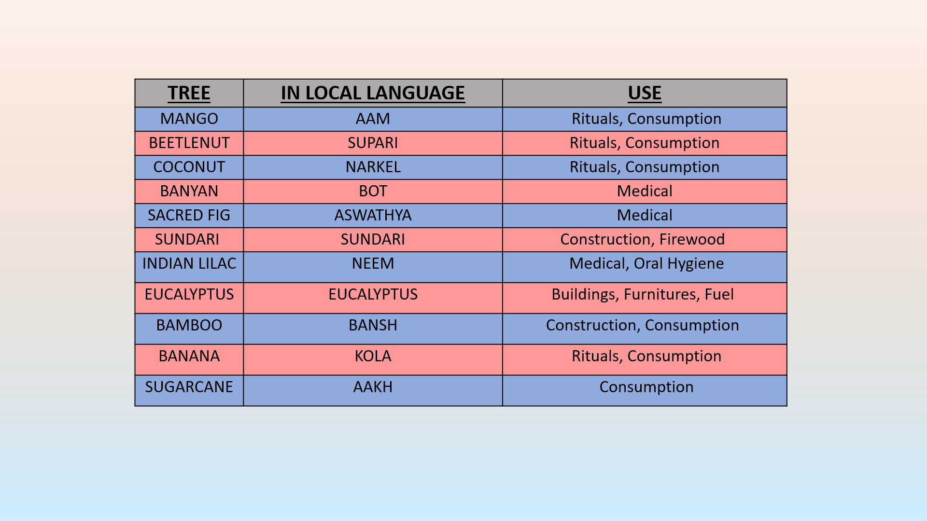

Table Local Flora & Fauna

**CHAPTER V**

**CLIMATE CHANGE**

The village, Kuemuri is located in the southern part of the West Bengal and it is near the delta region of Sundarbans and also very close to Bay of Bengal. So, climate threats like cyclones, heavy rain etc. are very common for the villagers.

In the recent years there were main two cyclones which devasted the southern part of Bengal- **Aila (2009)** and **Amphan (2020)**. The recent Amphan affected their life. Because of this the problems they are facing –

* Soil salinity level gone very high, after the cyclone it gone above 10 which resulted in death of fishes in ponds and crops started decaying.
* They could not grow paddy this season properly. The production out of 1 acre was very less. Currently they are trying to recover.

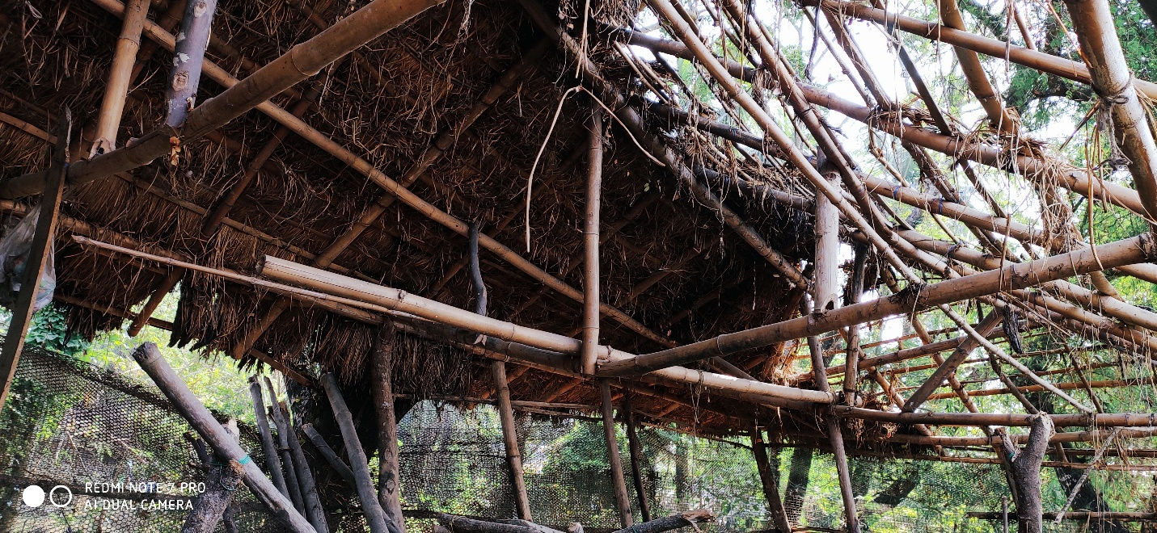

Figure Destruction by Amphan

**KEY LEARNINGS**

* **Learning from the Villagers**
* Rural Lifestyle
* Livelihoods
* Coping up with difficulties.
* **Learning from the Organization**
* Brief idea about FPO.
* Learnt Pond Based Integrated Farming.
* Process of Compost.
* **Learning from the Faculty Guide**
* Patiently solve problems.
* Proper way to do the internship.
* Right way to prepare the PPT.
* **Linking Theoretical Knowledge with Practical Knowledge**
* Implement PRA Tools.
* How Vulnerability affecting rural people’s Assets.
* Use of QT tools for analysis.

**ANNEXURES**

|  |  |  |
| --- | --- | --- |
| **1** | **Name of the Village** | **Kuemuri** |
| **2** | **Location of the Village** | **Heramba Gopalpur GP, Patharpratima Block, South 24 Parganas District, West Bengal** |
| **3** | **Name of the Sarpanch** | **Alpana Mondal** |
| **4** | **Date of Visit** | **7.1.2021** |

|  |  |  |
| --- | --- | --- |
| **Demographics of the Village** | | |
| **1** | **No. of Men** | **2407** |
| **2** | **No. of Women** | **2410** |
| **3** | **No. of Children** | **279 (0 to 6 yrs.)** |
| **4** | **Total Population** | **5096** |
| **5** | **High Schools** | **1** |
| **6** | **Primary Schools** | **2** |
| **7** | **Anganwadis** | **2** |
| **8** | **Temples** | **2** |
| **9** | **Post Offices** | **1** |
| **10** | **Banks** | **2** |
| **11** | **Cyclone Shelter** | **1** |
| **12** | **Primary Health Center** | **1** |